IET.tv automation instruction manual

File Name | Version | Release Date
IET.tv automation instruction manual | 1.0

Revision History:

Ver. No. | Author | Approver | Release Date | Description of changes
1.0 | Babban Chandak/Amit Gajinkar

Table of Contents

1 Required Software and Installation 3

2 Project Structure 25

3 Configuration File Details 27

4 Module Specific Configuration 30

5 System Specific Constraints 33

6 Module Specific Constraints 34

7 Issues 34

Required Software and Installation

- NUnit :
- NUnit is a unit-testing framework for all .Net languages.
- It is used to run test cases and apply verification points (asserts).

Installation Steps:
- Double click on Nunit-2.6.4 set up file
- Click on Run button

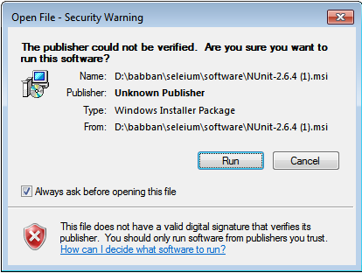
- Click on Next button
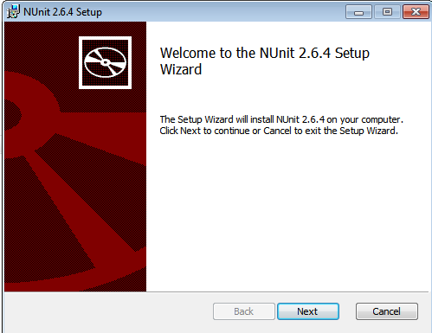

- Accept the Licence Agreement and click on Next button

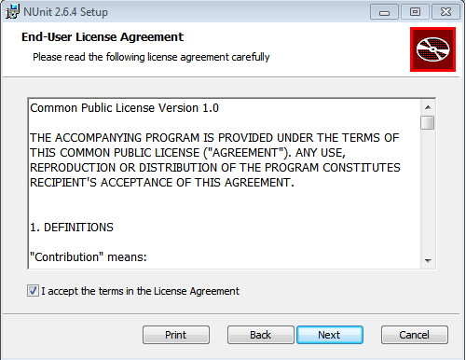

- Click on Typical button
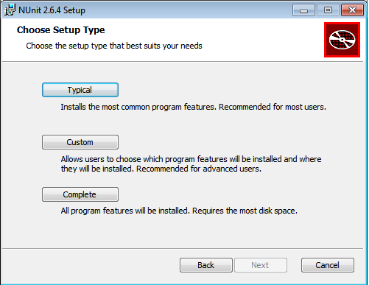

- Click on Install button

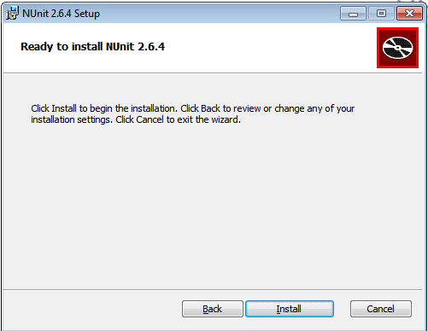

- Click on Finish button

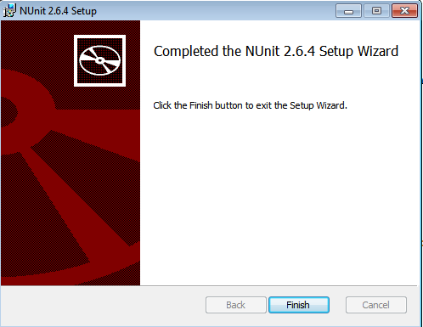

Steps to set up environment of Nunit:

- Go to path - Control Panel\System and Security\System
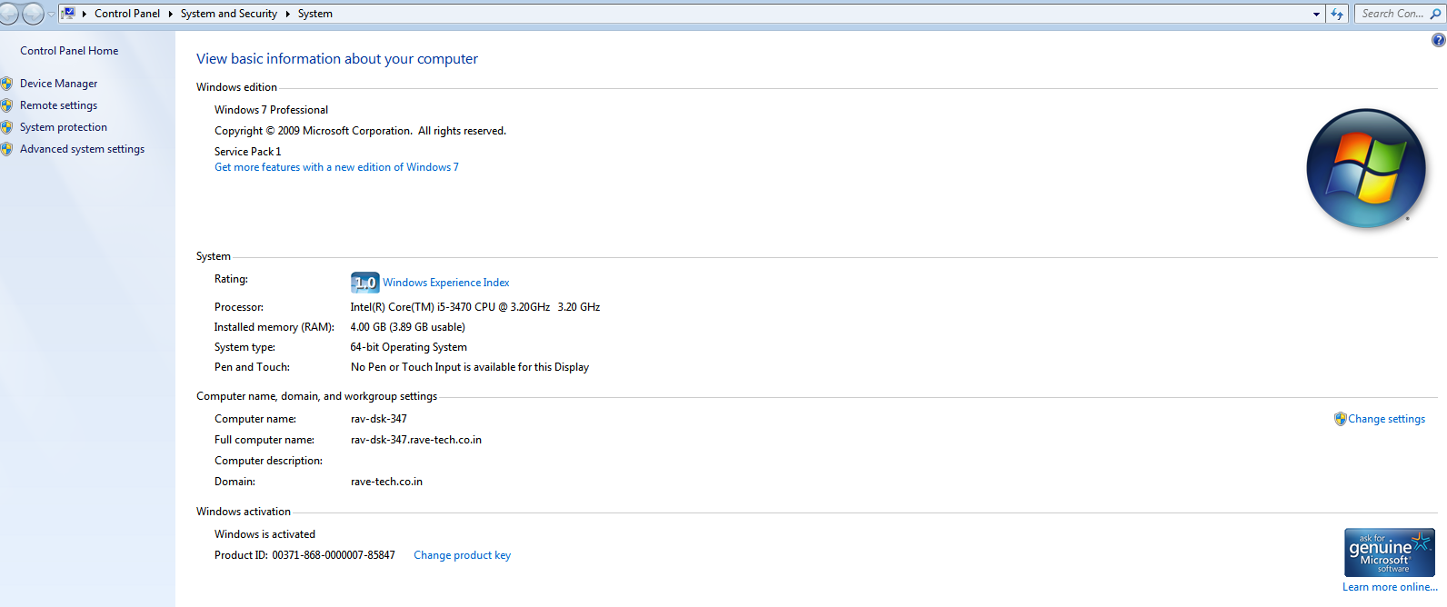

- Select Advanced system settings and click on Environment Variables button

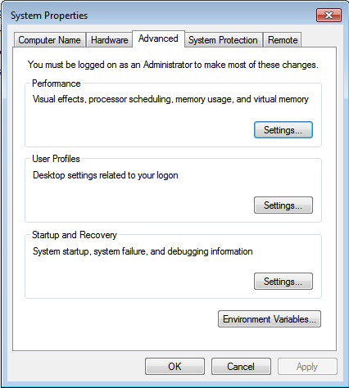

- Select variable ‘Path’ from system variables section and click on Edit button

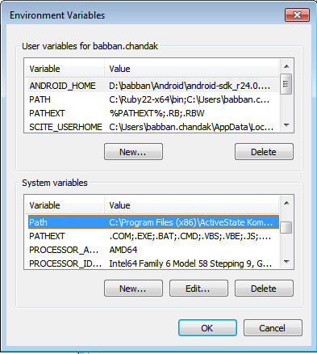

- Add path - C:\Program Files (x86)\NUnit 2.6.4\bin in ‘Variable value’ and click on OK button

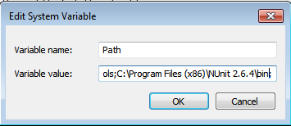

- Verify Nunit installed from command prompt by command : nunit-console.exe
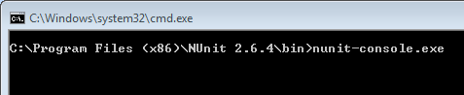

Gives output - NUnit-Console version 2.6.4.14350

- Configure Nunit for video recording

Set Corflags:

1. You can search the CorFlags.exe directly from windows explorer or from the command prompt by the following command
Open the cmd prompt (Start -> Run -> Type "cmd" -> OK or hit Enter Key).
Type "cd\" then hit Enter key. (This will change your current location to the root folder or top most folder)
Type "DIR /S CorFlags.exe" then hit Enter Key. (This will tell your computer to search for CorFlags.exe in your entire C drive)
If you are unable to find the file, you may download and install Windows or .NET SDK's from microsoft.com. My preference would be Microsoft .NET Framework SDK (64 bit version).
Once installed, change directory to where the CorFlags.exe was installed using the command "CD <path>", where <path> in this case it would be any of the following folders;
C:\Program Files\Microsoft SDKs\Windows\v6.0A\Bin
C:\Program Files\Microsoft SDKs\Windows\v6.0A\Bin\x64
C:\Program Files\Microsoft.NET\SDK\v2.0 64bit\Bin

2. Run CorFlags using the syntax: CorFlags <application> /force /32BIT+, where <application> is the application name including its full path.
Example: CorFlags " C:\Program Files (x86)\NUnit 2.6.4\bin\nunit-console.exe" /force /32BIT+
In any case you get an error message like this:
corflags : error CF001 : Could not open file for writing. This can be resolved by giving write permission to the current user on the path where the application is located. For instance, here it would be on " C:\Program Files (x86)\NUnit 2.6.4\bin” folder.

3. To enable write access to the current user using windows explorer;
Launch Windows Explorer and go the folder where the application is located.
Right click on the folder and select Properties. Click Security tab and then Edit button just below the Group or user names list.
Select Users (<pc name>/Users) then check allow Full control check box.

4. Again run the CorFlags.exe. This time it should successfully flag the application to run on 32 bit mode

- SmartBear agent :
- Description: The Test Agent needs to be installed and configured on computer(test host) that will run automated tests.
- Steps to set up:
- Login to QAComplete smartbear with valid user credentials
- Download the Agent’s installation file from from Test Management / Test Hosts from the Download Test Agent link in the light blue toolbar.

- Run the installation and follow the Installation Wizard instructions.
- On the Register Test Agent in QAComplete page of the wizard, register the agent in your QAComplete service:
- In the Web text box, enter the address of your QAComplete web service.
- The address is https://qacomplete.smartbear.com/rest-api/service
- In the User and Password text boxes, enter the e-mail address and the password that you use to log in to your QAComplete account. Click Next to continue
- On the Logon page of the installation wizard, specify the user account to use for running your tests from this machine.
- In the User Name and Password text boxes, enter the name and the password of the user account. If the user account belongs to a domain, enter the user name along with the domain name. For example, MyDomain\JohnSmith.
- Note: The above user should have an administrator rights on the test host
- Click Next to complete the installation.
- Once the Test Agent is installed on your computer, the Agent automatically creates a Test Host record in QAComplete's Test Management.

Configuring the Test Agent Once the Test Agent is installed on your machines:
- Go to Start - All Programs - SmartBear - Test Agent - Test Agent Settings
- In the Service Address field, enter the Address of the Agent Service
https://qacomplete.smartbear.com/rest-api/service
- In the Email Address and Password fields, enter the email address and password you use to log in to your QAComplete account
- In the User Name and Password, enter the name and password for the Windows user account that will run the automated test from this machine.
Note: If the account belongs to a domain, make sure to enter the domain name along with the user name ([my domain/my domain user name])
- Click OK to save your changes
- Select ‘Use active session’ checkbox option

- Smart bear Scheduler:
Scheduling Automated Tests Automated Tests or Test Sets can be configured to run independently of any user interaction by putting the Tests on a Test Schedule.
The Schedule can be a one-time scheduled run, or it can be a recurring schedule repeated on specific days of the week.
In Test Management, click Test Schedules.
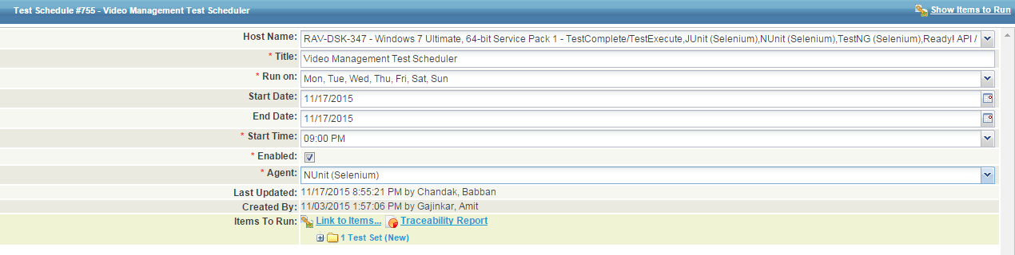
On the Test Schedules listing form, click Add New to create a new schedule.
On the Add Test Schedule form, enter the information for the new schedule.
In the Title field, give the schedule a meaningful Title.
In the Hosts list, select the Test Host that will run the test and holds the Nunit project suite. The list is populated with the machines where the Test Agent is installed and running
In Run On, choose the days of the week to run the Automated Test.
Use the Start Date and End Date to define the date range that the schedule will be active. The schedule won't run until your start date, then will run as scheduled until the end date.
In Time Run, select the hour of the day when you want the Automated Test to run.
In the Agent list, select Nunit.
In Items to Run, link your Automated Tests or Test Sets. These Tests or Test Sets will run on the Test Host in the order of selection.
Click Submit to save the schedule. At the scheduled time, the Test Agent will kick off the associated Test or Test Set on the Test Host selected for the Schedule.

Note:
- If the Tests are associated with a Test Host, the Host on the Schedule takes precedence: your test are run on the Test Host on the Schedule, not the Host associated with the Test in the Test Library.
- Need to setup Time Zone : Setup/System Options as per your local time zone
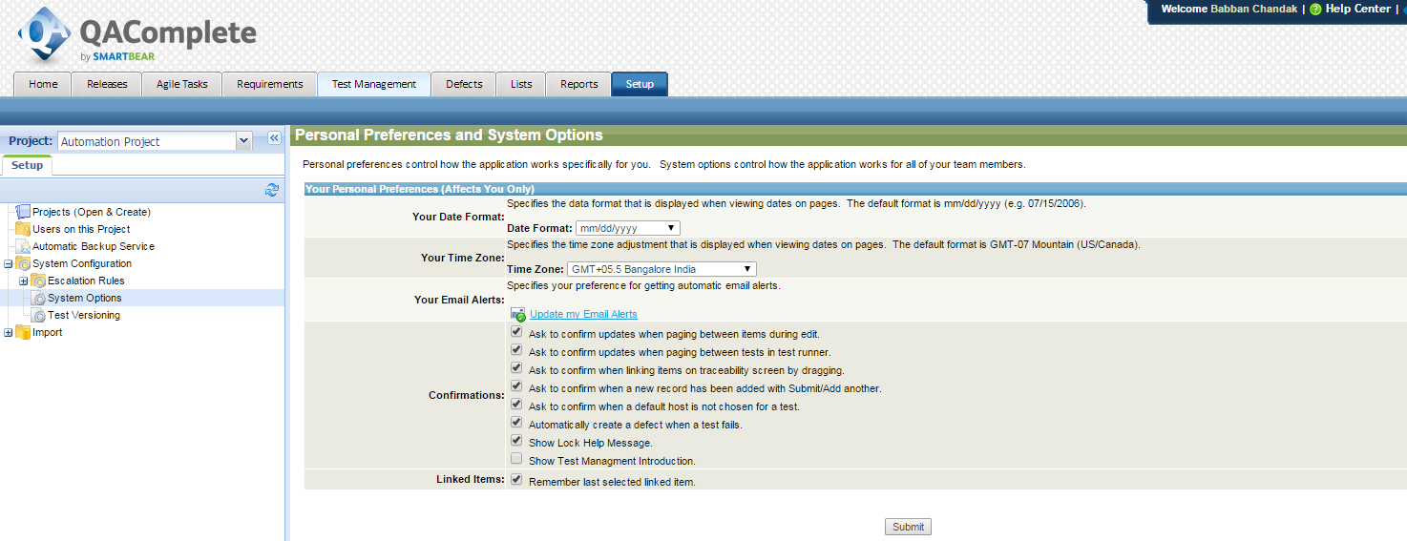

- Microsoft Expression Encoder 4 with Service Pack 2 (SP2) – On test host
- Click on Encoder_en exe file
- Click on Accept button

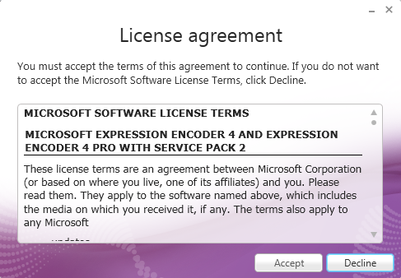

- Click on Next button

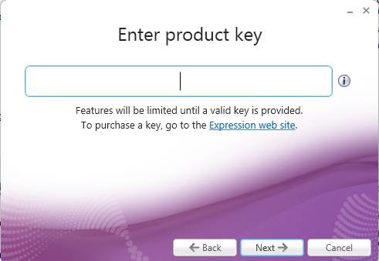

- Click on Next button
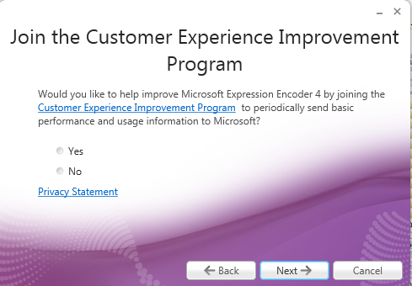

- Click on install

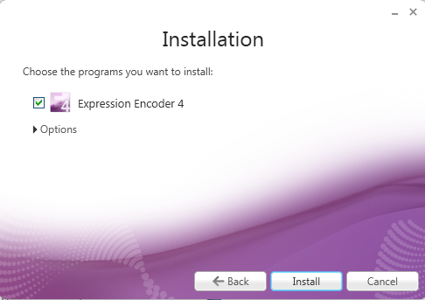

- Click on finish button
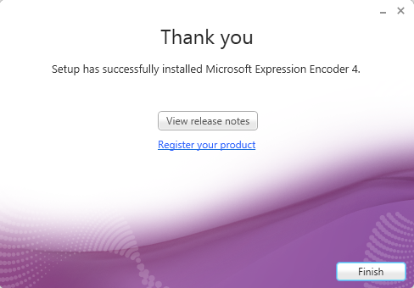

- .Net framework: Version – 4.5.1(need to install if not already present on test host)

- Java - java version "1.8.0_45"

- Setup ‘jre’ environment path (Test host) and ‘sikuli’ environment path:

- Go to path - Control Panel\System and Security\System

- Select Advanced system settings and click on Environment Variables button

- Select variable ‘Path’ from system variables section and click on Edit button

- Add path - C:\Program Files (x86)\Java\jre1.8.0_45\bin in ‘Variable value’ value’

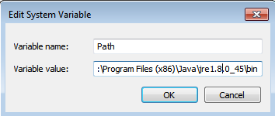

- Setup sikuli environment path – Add path - C:\Sikuli\libs in ‘Variable value’ value’ and click on OK button
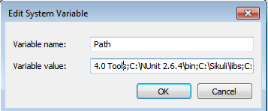

- Prerequisites to set up sikuli
- Allow access to javaw:
- Steps –
- Go to Path - Control Panel\System and Security\Windows Firewall and click on ‘Allow program or feature through Windows firewall” from left

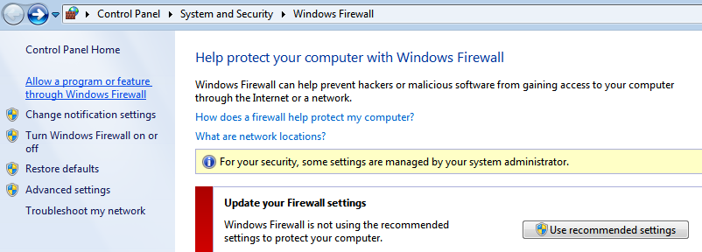

- Click on ‘Allow another program’ button

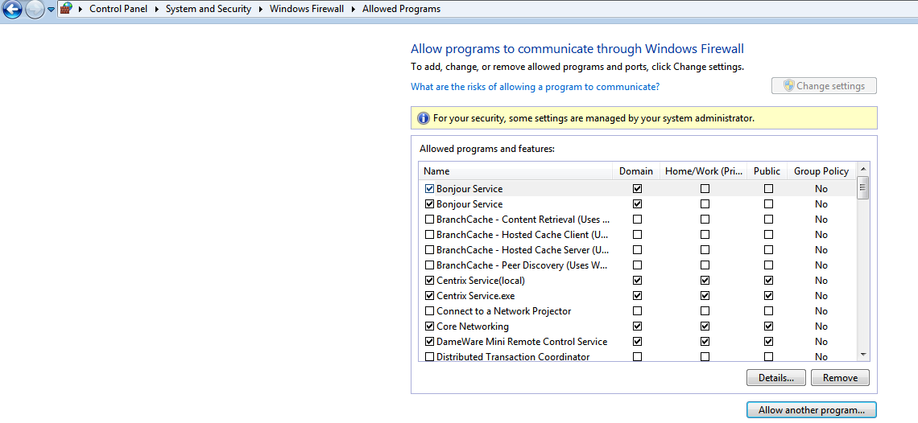

- Click on Browse button

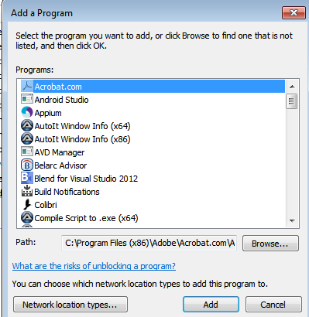

- Go to path “C:\Program Files (x86)\Java\jre1.8.0_45\bin” and select ‘javaw’

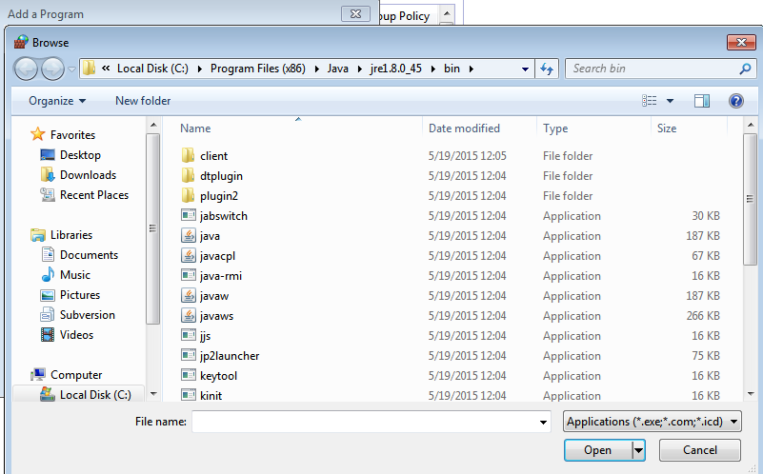

- Click on Add button

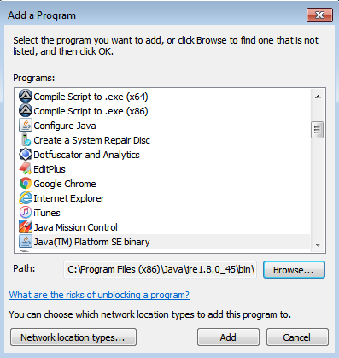

- Give access to ‘Java(Tm) Platform SE binary’ by clicking all permission check box

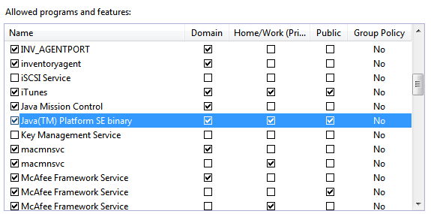

- Sikuli - Firewall setting

- Go to path - Control Panel\System and Security\Windows Firewall and click on Advance settings from left side.

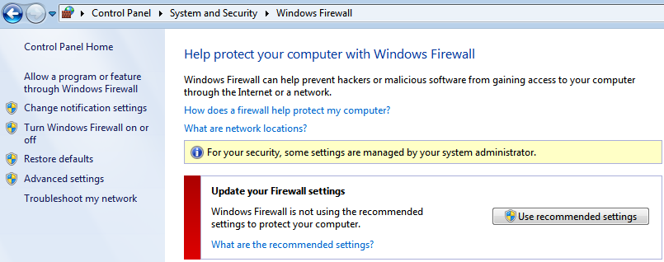

- Click on Inbounds Rule

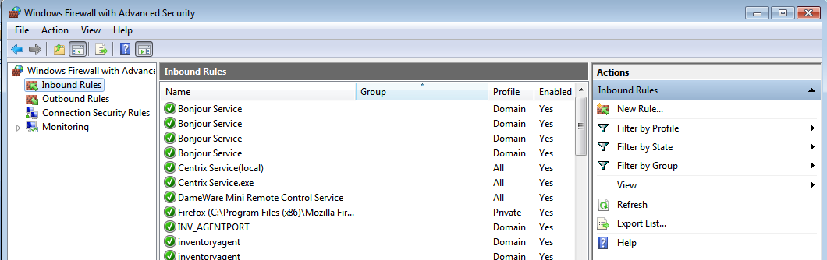

- Click on New Rule – Select Port radio button and click on Next

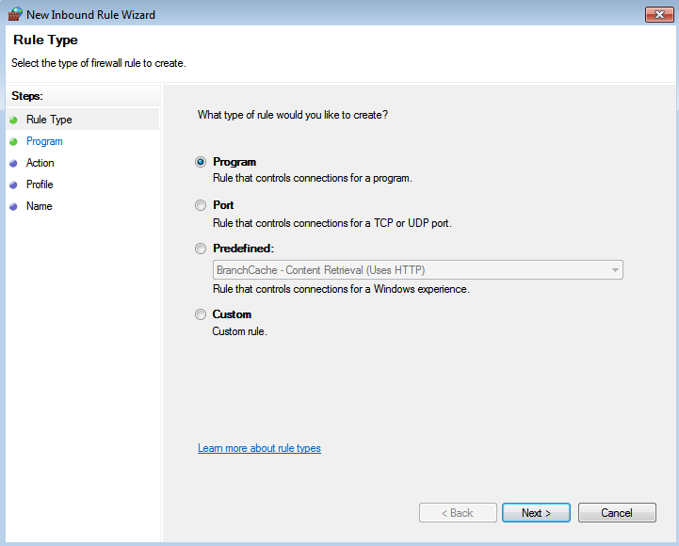

- Enter Port value as 8080 with TCP radio button should be selected and click on Next

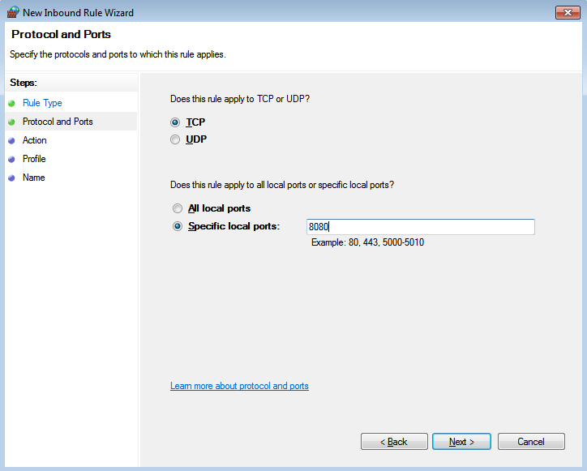

- Click on Allow the Connection and click on Next

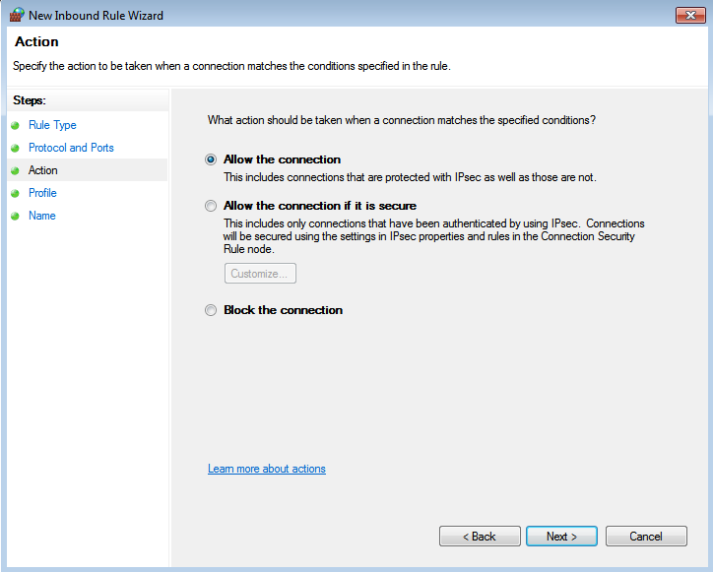

- Click on Next

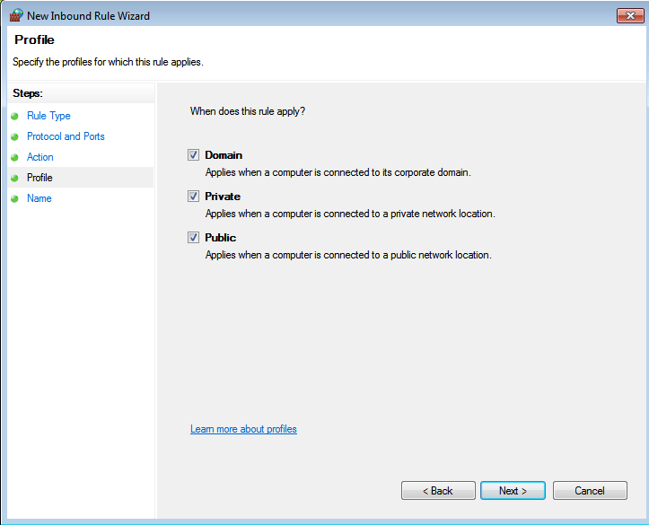

- Enter name as port8080 and click on finish button

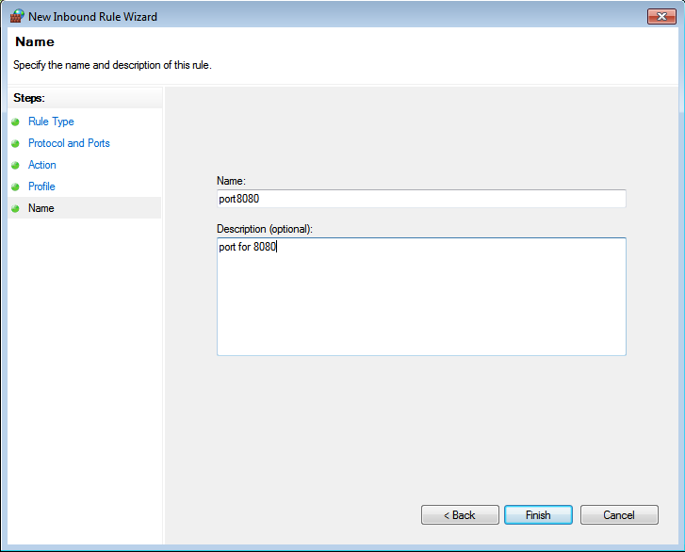

Project Structure

- Below Screen shot defines the project structure of IET.tv automation.

- The given project folder should be copied to C: drive. So the complete path of the project will be- C:\Project\IETTVWebPortal

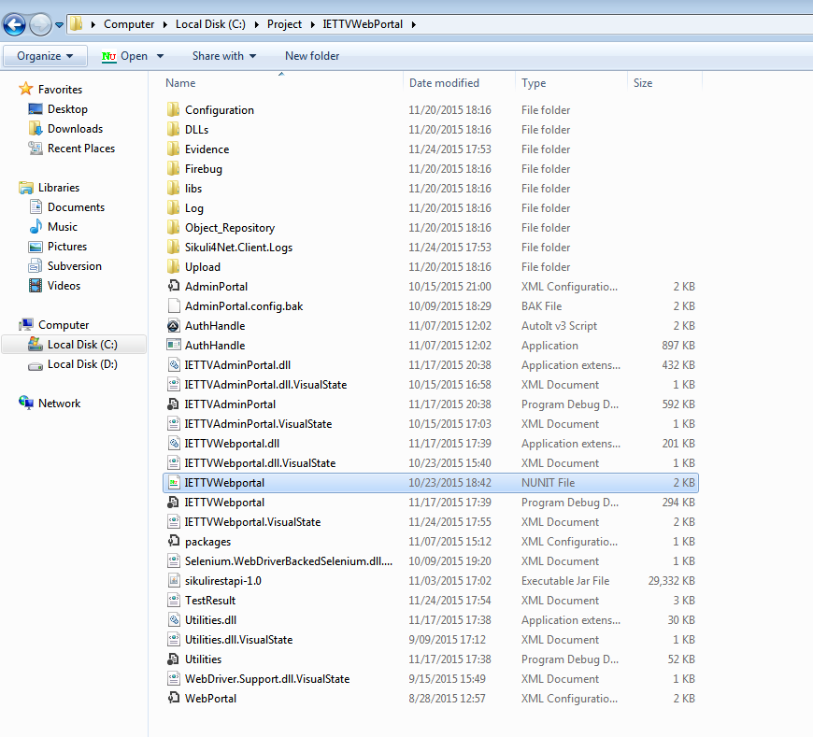

- Folder Description:
- Configuration – Contains user configuration and system configuration file in xml format
- DLLs – This folder contains all the dll required to run the test
- Evidence – Video recording of all the tests
- libs – All dependency dlls required for sikuli
- Log – Log files in text format of all the tests executed
- Object_Repository - It is a collection of object to locate the element of both admin and web portal
- Sikuli4Net.Client.Logs – log files regarding sikuli are generated in this folder

- Upload – Files required at the time of upload
Details of upload folder:
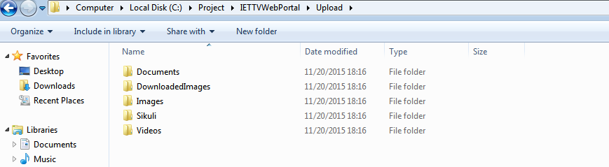

- Documents – User can add document he wish to upload
- DownloadedImages – In some scenarios we need to compare image for that we need to download that image. this folder contains all that downloaded images
- Images – User can add Images that he wants to upload
- Sikuli – Images need for sikuli are stored in this folder
- Videos – User can add Videos that he wants to upload

3 Configuration File Details

- Config.xml:
- Stores the details of all the modules needed to run test
- User can update config file as per requirement needed to run test

Example:
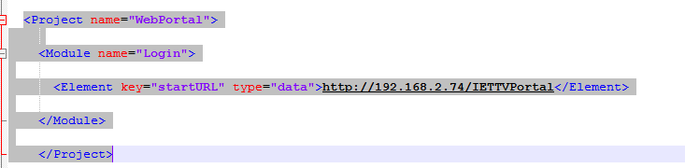
- Under ‘startURL’ key user need to update WebPortal Url

- SysConfig.xml:
- Global system setting details.
- User can update this file as per system setting that needs to be done.

Example:
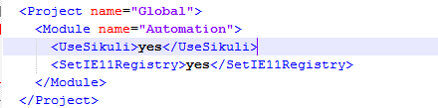

- Under ‘UseSikuli’ key user can update ‘yes’ or ‘no’ option to run sikuli or not

Note: In SysConfig.xml file if user keep key ‘UseSikuli’ value as ‘yes’ then at admin portal user authentication pop up will appear
If user keep key ‘UseSikuli’ value as ‘no’ then user who is logged into the system will automatically will logged into the IET.tv admin portal(Authentication pop will not appear)
Following one time setting needs to be done to disallow the admin authentication pop up at IET.tv admin portal

Steps :
1. Go to internet explorer – Internet option – Security-click on custom level

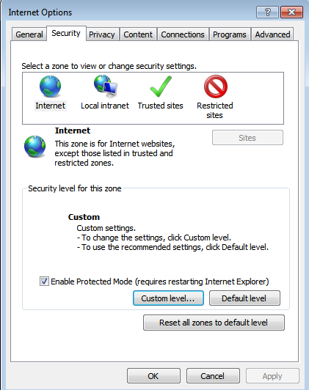

2. Setting – User Authentication – Logon – Select radio button “Automatic logon with current username and password”
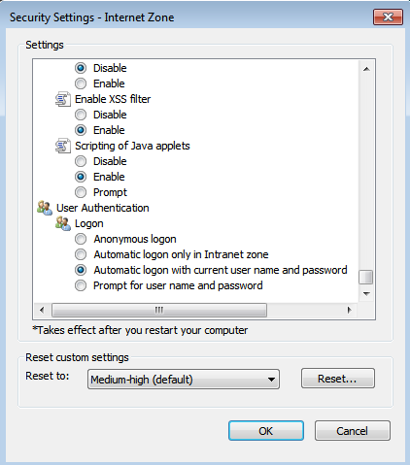

Module Specific Configuration
- Below is the screen shot of the Config.xml file:
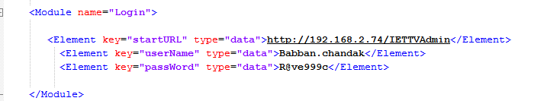

- Video management
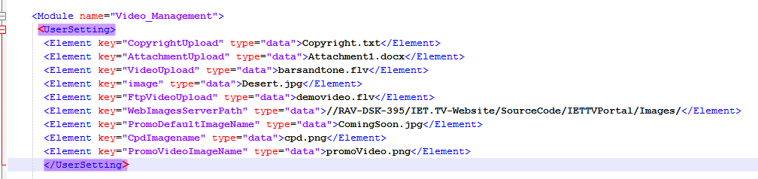

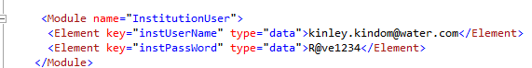

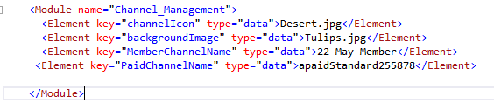

- Poll management

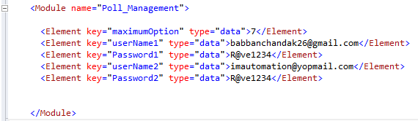

- List of all keys with its description:

Config.xml
Module Name | key | Description
Login | <Element key="startURL" type="data"> | Admin Portal Url
Login | <Element key="userName" type="data"> | Admin user name
Login | <Element key="passWord" type="data"> | Admin user password
Video Management | <Element key="CopyrightUpload" type="data"> | File name to upload copyright
Video Management | <Element key="AttachmentUpload" type="data"> | File name to upload attachment
Video Management | <Element key="VideoUpload" type="data"> | File name to upload video
Video Management | <Element key="image" type="data"> | File name to upload speaker
Video Management | <Element key="FtpVideoUpload" type="data"> | File name to upload video by ftp
Video Management | <Element key="WebImagesServerPath" type="data"> | Path where default images exist
Video Management | <Element key="PromoDefaultImageName" type="data"> | File name to select default promo image
Video Management | <Element key="CpdImagename" type="data"> | File name to upload cpd image
Video Management | <Element key="PromoVideoImageName" type="data"> | File name to upload promo video
Video Management | <Module name="InstitutionUser"> <Element key="instUserName" type="data">  <Element key="instPassWord"  type="data"> | User credentials required to like and dislike video
 | <Module name="Channel_Management">  <Elementkey="MemberChannelName"  <Element key="PaidChannelName" | Required to select channel from channel tab in Video management model
Poll Management | <Element key="userName1" type="data">  <Element key="Password1" type="data"> | First user credential for submitting poll
Poll Management | <Element key="userName2" type="data">  <Element key="Password2" type="data"> | Second user credential for submitting poll
Poll Management | <Element key="maximumOption" type="data"> | User can set maximum number of answers to a question for a poll

NOTE: If user wants to upload any other file other than files which are already present in ‘Upload’ folder path: C:\Project\IETTVWebPortal\Upload
Example: In Upload folder we have Video folder which contains video named as “barsandtone.flv”, if user wants to upload any other video (E.g.: video.mp4) then he needs to:
- Add that video in video folder
- Also needs to update config.xml file.
E.g.: For video user needs to replace key” VideoUpload” value from “barsandtone.flv” to “video.mp4”.

System Specific Constraints

- Sikuli – System needs to be in unlock state and current window should not be overlapped by any other window on which sikuli operation is getting performed
- Video recording(Evidence) - System needs to be in unlock state
- No interruption should be done once test execution started
- IET.tv Admin user credentials needs to be updated in config.xml file
- SmartBear scheduler – Scheduler Runs the test with delay of 8 to 10 minutes(As confirmed with smartbear team)
- While executing tests database record will get increase, because of which it might slow down the test execution – it is advisable to clean database (Manually) if number of records gets increase. (For the applicable modules only)
- The admin portal credentials should be unique for each host in the configuration file
- The maximum execution timeout in SmartBear is set to 25minutes.
- Currently configuration support only one SmartBear and multiple host but does not support multiple SmartBear and Multiple host
- All Test executed on the Operating system windows-7 in chrome browser
- Temp folder should be cleared at regular interval

Module Specific Constraints
- Video Management – We are waiting for max of 120 sec after clicking on publish button to get video to be published

Issues

Module | Issue | JIRA – SMARTBEAR ID | Impacted Tests
Poll Management | Search By dropdown has only four option when Video radio button is selected | TV-263 - 3346409 | None
Poll Management | Not able to see Poll panel on event landing page. | TV-264 - 3346408 | TVAdmin_003_PollManagementFuncForEvent,  TVAdmin_005_PollActivateInactivateForEvent,  TVAdmin_005_PollingDisplayFuncForEvent
Poll Management | Update functionality under Poll management is not working. | TV-265 - 3346407 | TVAdmin_004_PollActivateInactivateForVideo,  TVAdmin_005_PollActivateInactivateForEvent

